 | AYDIN ADNAN MENDERES UNIVERSITY  ENGINEERING FACULTY COMPUTER  ENGINEERING DEPARTMENT | 

Performance Comparison of Various Loss Functions in Benchmark Datasets

Cavit Eren Yıldız - Supervisor: Assoc. Prof. Dr. Fatih Soygazi

Aydın Adnan Menderes University, Computer Engineering Department, Aydın Türkiye, 201805001@stu.adu.edu.tr
Aydın Adnan Menderes University, Computer Engineering Department, Aydın Türkiye, ftekbacak@adu.edu.tr

Keywords
Loss Functions
Benchmarking
Multi-modal Datasets
Model Performance
Deep Learning

Abstract
Choosing an appropriate loss function is a critical design decision directly impacting the convergence speed, optimization efficiency, and generalization of deep learning models. Existing comparative studies often isolate loss functions within single data modalities or homogenous architectures, leaving their structural fragilities unexamined under diverse constraints. To address this, this study presents a comprehensive empirical evaluation of various loss functions across five distinct data modalities: tabular, image, text, time-series, and environmental audio. We conducted ten controlled experiments across an architecture-spanning framework bridging baseline methods, multi-layer perceptrons, and 1D/2D convolutional neural networks. Under a unified protocol, standard cross-entropy variants, distance-based margin objectives, and robust alternatives were systematically benchmarked. The findings validate that optimal performance is structurally dictated by underlying data geometry, noise, severe imbalance, and target scale topology. The comparative analysis establishes a robust mapping under specific failure modes, demonstrating that strategic mathematical alignment of the loss function can enhance optimization success at lower computational costs. Ultimately, this multi-modal benchmarking provides actionable insights for selecting optimal loss functions based on application-specific requirements, serving as a comprehensive reference for designing stable deep learning architectures

1.Introduction

In machine learning, selecting and defining an appropriate loss function is a foundational task that governs how a model learns from data. This task involves establishing a mathematical metric to quantify the discrepancy between predictions and ground truth, directly guiding the optimization algorithm during training. This choice is of paramount importance because it serves as the core driver of model behavior, directly determining optimization efficiency, convergence speed, and generalization performance across both traditional methods like logistic regression and complex deep networks. A mismatched loss function severely degrades model performance, leading to slow training or suboptimal decision boundaries. As machine learning systems expand into diverse real-world domains, systematically understanding and benchmarking how different loss formulations impact predictive behavior is essential for engineering reliable intelligent systems.
Previous studies have addressed this challenge by developing specialized loss functions tailored to specific tasks. Typically, researchers evaluate these formulations by isolating a single modality, such as testing cross-entropy variants exclusively on computer vision datasets. However, comprehensively benchmarking these solutions is difficult due to two main complexities. First, a loss function’s efficacy depends heavily on model complexity; a formulation that stabilizes a baseline model like logistic regression may underperform or cause optimization bottlenecks in deep neural networks. Second, data characteristics vary drastically across modalities, meaning that handling class imbalance in text requires fundamentally different gradient updates than managing noise in audio. Because loss functions exhibit highly non-linear behaviors across different datasets and architectures, conducting a unified, multi-modal evaluation remains a major challenge.
Current benchmarking approaches fail when standard loss functions are applied blindly to non-standard environments, such as datasets with severe class imbalance, high label noise, or structural variations across modalities. In these scenarios, traditional metrics like cross-entropy often fail by biasing the model toward majority classes or overfitting to corrupted labels, a vulnerability that becomes even more unpredictable when moving from simple logistic regression to deep architectures. Solving these failure cases is critical because real-world deployment demands reliability across imperfect data conditions. By identifying exactly where and why specific loss functions fail, researchers can prevent catastrophic model decisions, optimize computational resource allocation, and develop robust, adaptive loss strategies that maintain stable performance regardless of dataset anomalies.
To address these limitations, this study presents a systematic and comprehensive evaluation of various loss functions across a diverse suite of benchmark datasets. We conducted ten distinct experiments to analyze model performance across multiple data modalities, ranging from traditional statistical baselines like logistic regression to advanced deep learning architectures. By rigorously testing these configurations under varied conditions, we provide a unified framework that maps loss function efficacy to specific dataset characteristics and model complexities.
The primary contributions of this work are as follows:
- Multi-Modal Benchmarking: We provide an extensive comparative analysis of loss functions across diverse data modalities, breaking the isolation found in single-domain literature.
- Architecture-Spanning Evaluation: We bridge the gap between traditional and modern approaches by evaluating loss behaviors from foundational logistic regression to complex deep neural networks.
- Robustness Mapping under Failure Modes: We systematically identify the failure points of standard loss metrics and offer empirical guidelines for selecting optimal loss functions under challenging data constraints like class imbalance and noise.

2. Related Work

2.1. Evolution and Computational Complexities of Predictive Models

The landscape of predictive modeling has evolved drastically, moving from foundational statistical methods to highly parameterized deep learning architectures. Early implementations relied heavily on linear approaches and logistic regression due to their mathematical tractability, ease of interpretation, and low computational overhead in resource-constrained environments. As computational power increased and datasets expanded, the paradigm shifted toward deep neural networks capable of automatically learning hierarchical feature representations. However, a significant gap in current literature is that existing comparative studies usually isolate these methodologies; they either evaluate loss functions solely within traditional statistical frameworks or exclusively inside deep learning paradigms. This compartmentalization leaves the transitional behavior of loss functions largely unexamined. Our work differs from and addresses this gap by creating a unified benchmarking environment. By executing ten distinct experiments that span from baseline logistic regression to complex deep networks, we systematically map how the scale and depth of an architecture influence the optimization trajectory and efficacy of identical loss formulations.

2.2. Methodological Categorization and Structural Fragilities of Loss Functions

Loss functions in machine learning can be broadly categorized into distinct classes based on their mathematical objectives, such as distance-based errors (e.g., Mean Squared Error), probabilistic margins (e.g., Cross-Entropy), and cost-sensitive or robust alternatives (e.g., Focal Loss, Huber Loss). While each class is theoretically optimized for specific distributions, a critical gap persists in how these methods are validated: most methodologies evaluate loss functions within a single, homogenous data modality. Consequently, the structural fragilities of these function classes remain hidden until they encounter real-world domain anomalies like extreme class imbalance or high label noise across differing formats. Our study explicitly addresses this limitation by conducting a cross-modal evaluation across tabular, image, text, time-series, and audio datasets. Instead of observing a loss function class in isolation, we subject each category to heterogeneous environments, revealing exactly where traditional probabilistic margins fail and how cost-sensitive formulations mitigate those structural vulnerabilities.

3. Methodology and Experimental Design

This section describes the systematic approach used to evaluate the impact of different loss functions across various data domains. To ensure scientific rigor, all experiments followed a unified pipeline consisting of data preprocessing, model selection, and a controlled training environment.

Table 1. The model and loss function used for all experiments.
Dataset | Type | Used Models | Loss Functions
Titanic | Tabular | LR, MLP | BCE, WBCE, Focal, Hinge
Breast Cancer | Tabular | LR, MLP | BCE, WBCE, Focal, Hinge
Fashion-MNIST | Image | CNN | CE, MSE, LS, FL
CIFAR-10 | Image | CNN | CE, MSE, LS, FL
IMDB | Text | LR, MLP | BCE, MSE, MAE, Huber, Margin
SMS Spam | Text | LR, MLP | BCE, MSE, MAE, Huber, Margin
California Housing | Regression | MLP | MSE, MAE, Huber, LC
Wine Quality | Regression | MLP | MSE, MAE, Huber, LC
FordA | Time Series | 1D-CNN | LC, MSE, FL, CE, LS
UrbanSound8K | Audio | 2D-CNN | CE, FL, LS
Note: BCE: Binary Cross-Entropy (Log Loss), WBCE: Weighted Binary Cross-Entropy, MSE: Mean Squared Error, CE: Cross-Entropy, LS: Label Smoothing, FL: Focal Loss, MAE: Mean Absolute Error, LC: Log-Cosh Loss. The loss functions and models that yielded the best result in the experiments are highlighted in bold.

3.1. General Experimental Protocol

All models were implemented using the PyTorch framework. To ensure a fair comparison between loss functions, a standardized optimization strategy was adopted. The Adam optimizer was utilized with a fixed learning rate of 0.001. To guarantee the reproducibility of the results, all stochastic operations were governed by a fixed manual seed (Seed: 42).

3.2. Experiment on Classifying Tabular Data

The first stage of the study focuses on binary classification using tabular datasets, which are characterized by discrete and continuous features.

3.2.1. Dataset Selection and Properties

Two benchmark datasets with contrasting characteristics were selected. The first is the Breast Cancer Wisconsin Diagnostic dataset, representing a high-dimensional but linearly separable medical task with 30 features and relatively balanced classes. The second is the Titanic Dataset, representing a noisy, real-world scenario characterized by missing values and significant class imbalance with an approximate 38% survival rate.

3.2.2. Preprocessing and Feature Engineering

Specific preprocessing steps were applied to prepare the raw tabular data for neural network training. First, missing values in the "Age" and "Cabin" features of the Titanic dataset were handled via mean and mode imputation, respectively. Next, categorical encoding was performed by converting qualitative variables into quantitative vectors using One-Hot Encoding. To prevent features with larger magnitudes from dominating the loss gradients, feature scaling was applied, normalizing all numerical inputs to zero-mean and unit variance via Standard-Scaler. The scaling parameters were computed strictly on the training set to avoid data leakage. Finally, data partitioning was conducted by splitting each dataset into 70% Training, 15% Validation, and 15% Testing sets using stratified sampling to maintain class proportions.

3.2.3. Model Architectures

To analyze how loss functions interact with model capacity, two distinct architectures were implemented. The first is Logistic Regression (LR), which is a single-layer linear model used to establish a performance baseline for simple decision boundaries. The second is a Multi-Layer Perceptron (MLP), representing a deep architecture that consists of hidden layers with 64 and 32 neurons, utilizing ReLU activation functions to capture non-linear feature interactions.

3.2.4. Loss Functions Under Evaluation

In this task, four criteria were analyzed: Binary Cross-Entropy (BCE) as the baseline, Weighted BCE for imbalance handling, Focal Loss for focusing on hard examples, and Hinge Loss for margin-based classification.

3.3. Experiment on Classifying Image Data

In this section, the technical framework established for evaluating loss functions on image-based benchmark datasets is detailed. The focus is placed on the CIFAR-10 and Fashion-MNIST datasets, representing distinct challenges in color and grayscale image recognition, respectively.

3.3.1. Dataset Characteristics and Preprocessing

The experiments utilize two widely recognized benchmarks to ensure the robustness of the comparative analysis. The first benchmark is CIFAR-10, which consists of 60,000 32 x 32 color images across 10 mutually exclusive classes, such as airplanes, automobiles, and birds. The second benchmark is Fashion-MNIST, comprising 70,000 28 x 28 grayscale images of clothing items categorized into 10 distinct classes, serving as a more complex replacement for the original MNIST dataset. To maintain consistency across experiments, all pixel values were normalized to the range of [0,1] by dividing the raw intensity values by 255. No further data augmentation techniques were applied to ensure that the performance variations observed are strictly attributable to the loss function dynamics rather than synthetic data variations.

3.3.2. Model Architecture

A Convolutional Neural Network (CNN) architecture was implemented for both datasets. The model consists of sequential convolutional layers designed to extract spatial features effectively. For feature extraction, two convolutional layers with 3 x 3 kernel sizes were utilized, followed by Max-Pooling layers to reduce dimensionality. For the classification head, the flattened feature maps are fed into a fully connected (Dense) layer, culminating in a Softmax output layer representing the 10 target classes.

3.3.3. Training Configurations & Hyperparameters

The training phase was standardized across all loss function variants to facilitate a fair comparison. Regarding the hyperparameter settings, the Adam optimization algorithm was chosen as the optimizer for its efficient handling of sparse gradients and adaptive learning rate capabilities. A fixed learning rate of 0.001 was maintained throughout the training cycles, and the experiments were conducted with a batch size of 64. Finally, the models were trained for a maximum of 50 epochs, with an Early Stopping mechanism implemented to monitor validation loss and prevent overfitting.

3.4. Experiment on Classifying (Text) Natural Language Processing (NLP)

The third phase of the experimental study evaluates the performance of loss functions on text-based classification tasks, focusing on short and long-form document structures.

3.4.1. Dataset Selection and Semantic Diversity

Two widely recognized NLP benchmark datasets were utilized to represent different linguistic challenges. The first is the SMS Spam Collection, which is a dataset consisting of short, informal messages characterized by high class imbalance and sparse feature distributions, serving as a testbed for evaluating model efficiency on concise text. The second is the IMDB Movie Reviews dataset, a large-scale dataset containing long-form, dense text that is used to assess the models’ ability to capture sentiment and semantic nuances in structurally complex documents.

3.4.2. Text Preprocessing and Vectorization

To transform raw text into a format suitable for neural network training, a standardized NLP pipeline was implemented. First, text cleaning was performed by lowercasing raw strings and removing non-alphanumeric characters to reduce noise. For numerical vectorization, the TF-IDF (Term Frequency-Inverse Document Frequency) method was employed to convert the text into fixed-size numerical vectors, where a maximum vocabulary size of 3,000 features was selected to balance information density and computational efficiency. Finally, during data partitioning and consistent with the previous tasks, the processed vectors were split into 70% Training, 15% Validation, and 15% Testing sets using stratified sampling to preserve label ratios.

3.4.3. Model Architectures

The models were designed to evaluate how text-derived features interact with varying network depths. A linear baseline was established using Logistic Regression (LR) to measure the separability of the TF-IDF feature space. Additionally, a non-linear Multi-Layer Perceptron (MLP) featuring a hidden layer with 64 neurons and ReLU activation was implemented, which is intended to capture higher-order feature interactions within the 3,000-dimensional input space.

3.4.4. Evaluated Loss Functions and Metrics

For the NLP task, the investigation was expanded beyond standard classification criteria. In addition to Binary Cross-Entropy (BCE), the impact of regression-based losses—Mean Squared Error (MSE), Mean Absolute Error (MAE), and Huber Loss—was examined within the classification framework to analyze their robustness against semantic noise. Performance was quantified using Accuracy, Precision, Recall, and F1-Score metrics.

3.5. Experiment on Regression Analysis Experiment

The fourth phase of the research evaluates the efficacy of various loss functions in a regression framework, focusing on the models’ ability to predict continuous numerical values and their robustness against variance in data scales.

3.5.1. Dataset Selection and Complexity

Two datasets with distinct statistical distributions were selected to test the predictive stability of the models. The first is California Housing, a large-scale dataset used to predict median house values, which is characterized by high dimensionality and complex geographical correlations that require the model to learn intricate mapping functions. The second is Wine Quality, a dataset focused on predicting the physicochemical properties of wine. Unlike the housing dataset, it features a more constrained target range, typically between 3 - 9, and requires higher sensitivity to subtle feature variations.

3.5.2. Preprocessing and Statistical Alignment

To ensure optimal convergence during the gradient descent process, a rigorous preprocessing pipeline was applied. For feature standardization, all input features were transformed using the StandardScaler method to achieve a mean of zero and unit variance. This alignment was achieved by subtracting the mean of each feature from its individual values and subsequently dividing the result by the standard deviation, which is critical for regression and deep learning tasks to ensure that features with larger magnitudes do not disproportionately influence the weight updates, thereby maintaining balanced gradients. Regarding data partitioning and target treatment, unlike the classification tasks where categorical labels are processed, the target variables in this section were maintained in their continuous form. To ensure reproducibility and comparative integrity, the dataset was partitioned into 70% Training, 15% Validation, and 15% Testing sets using a consistent random seed.

3.5.3. Model Architecture: Deep MLP

To capture the non-linear relationships inherent in regression tasks, a deeper Multi-Layer Perceptron (MLP) architecture was implemented. Regarding the layer configuration, the network consists of an input layer followed by four dense hidden layers with 128, 64, 32, and 16 neurons, respectively. For activation and output, ReLU activation functions were utilized between hidden layers to mitigate the vanishing gradient problem. The final output layer consists of a single neuron with a linear activation, allowing for the prediction of unbounded continuous values.

3.5.4. Evaluated Regression Loss Functions and Metrics

The experiments focused on comparing four distinct loss criteria, each with different mathematical properties regarding error penalization. First, Mean Squared Error (MSE) penalizes larger errors quadratically, making it highly sensitive to outliers. Second, Mean Absolute Error (MAE) provides a linear penalty, offering more robustness against anomalous data points. Third, Huber Loss serves as a hybrid approach that behaves like MSE for small errors and MAE for large errors, controlled by a transition threshold. Fourth, Log-Cosh Loss offers a smooth approximation of MAE that is twice differentiable, ensuring more stable gradients near the local minima. Performance was systematically quantified using Mean Absolute Error (MAE), Root Mean Squared Error (RMSE), and the Coefficient of Determination (R-
Squared) to evaluate both error magnitude and the proportion of variance explained by the model.

3.6. Experiment on Time-Series Experiment

The fifth phase of the study investigates the performance of loss functions on sequential data, specifically focusing on binary time-series classification. This task evaluates the models’ ability to extract temporal patterns from raw signal data.

3.6.1. Dataset and Temporal Characteristics

The FordA dataset was utilized for this experiment. This benchmark involves motor noise recordings where the objective is to determine the presence of a specific diagnostic symptom. Regarding its sequential nature, each sample consists of 500 temporal observations, representing a univariate time-series. In terms of complexity, the dataset is characterized by high variance and overlapping signal patterns, making it a robust testbed for evaluating the stability of gradient-based optimization under different loss criteria.

3.6.2. Signal Preprocessing and Data Structuring

Given the nature of the time-series data, specific structural adjustments were made. For standardization, the raw signals were normalized to ensure that the temporal fluctuations remained within a consistent numerical range, thereby facilitating faster convergence. For tensor shaping, the data was reshaped into a three-dimensional format consisting of samples, time steps, and features to be compatible with the input requirements of one-dimensional convolutional architectures. Finally, during partitioning, the dataset was divided into 70% Training, 15% Validation, and 15% Testing subsets while strictly maintaining the sequential integrity of the recordings.

3.6.3. Model Architecture: 1D-CNN

To capture the local dependencies and temporal features within the signal, a One-Dimensional Convolutional Neural Network (1D-CNN) was implemented. Regarding the feature extraction layers, the architecture features three sequential 1D-Convolutional layers, where each layer is followed by Batch Normalization to stabilize training and a ReLU activation function for non-linearity. For global pooling, a Global Average Pooling layer was utilized after the final convolution to reduce the feature map to a single vector, significantly reducing the number of parameters and preventing overfitting. The network then concludes with an output layer consisting of a dense layer and a Sigmoid activation function for binary classification.

3.6.4. Evaluated Loss Functions and Sequential Metrics

The impact of loss functions was tested using Binary Cross-Entropy (BCE), Weighted BCE, Focal Loss, and Hinge Loss. The evaluation focused on the models’ ability to maintain high precision in signal detection despite the inherent noise in the temporal sequences. Performance was assessed via Accuracy, F1-Score, and the area under the ROC curve (AUC-ROC) to measure diagnostic reliability.

3.7. Experiment on Audio Data

This section outlines the methodological approach for evaluating loss functions in the domain of audio signal processing, specifically focusing on environmental sound classification.

3.7.1. Dataset and Feature Extraction

The UrbanSound8K dataset was employed as the primary benchmark for audio classification. This dataset contains 8,732 labeled sound excerpts of urban sounds from 10 classes, such as street music, jackhammer, and siren. Given that deep learning models, particularly Convolutional Neural Networks (CNNs), achieve superior performance on visual representations of sound, the raw audio files were transformed into Mel-Spectrograms. The feature extraction process involved several sequential steps. First, all audio clips were standardized to a sampling rate of 22,050 Hz. For windowing, a Fast Fourier Transform (FFT) window size of 2048 and a hop length of 512 were utilized. Finally, the resulting power spectrograms were mapped onto a Mel scale with 128 bands using Mel-Filterbanks to align the features closely with human auditory perception.

3.7.2. Model Architecture for Audio Signals

A specialized 2D-CNN architecture was implemented to process the Mel-spectrogram features, designed specifically to capture both temporal and spectral patterns within the audio signals. The structural pipeline consists of multiple convolutional layers with small kernels used to detect fine-grained acoustic features. Following these layers, max-pooling operations were applied to reduce spatial dimensions, while dropout layers with a rate of 0.25 were integrated to enhance model generalization and prevent overfitting on specific environmental noises. The network concludes with a final dense output layer utilizing a Softmax activation function to provide the probability distribution across the 10 urban sound categories.

3.7.3. Training Protocol

To maintain a rigorous comparative framework, the training parameters were kept entirely consistent with previous experiments. The Adam optimizer was utilized with a fixed learning rate of 0.001. The primary objective of this configuration was to observe the convergence speed and final accuracy of various loss functions when dealing with the high-variance nature of environmental audio. To ensure the statistical significance of the empirical results, a 10-fold cross-validation approach was applied, strictly maintaining consistency with the original UrbanSound8K fold structure

4. Experimental Results

In this section, the empirical findings derived from the conducted experiments are systematically presented. The quantitative and qualitative outcomes are illustrated using comprehensive tables, comparative graphs, and evaluation matrices. To facilitate a structured assessment, each experiment is supported by relevant visual data, accompanied by detailed textual explanations that interpret the strategic mathematical alignment and trade-offs of the respective loss functions..

4.1. Tabular Data Experiment Results

4.1.1 Titanic Dataset Experiment Results

Table 2. Performance Metrics - Titanic Dataset
Model | Loss Function | Accuracy | Precision | Recall | F1-Score | ROC-AUC
Logistic Regression | Weighted BCE | 0.5821 | 0.4561 | 0.5098 | 0.4815 | 0.5821
Logistic Regression | Focal | 0.6194 | 0.5000 | 0.3725 | 0.4270 | 0.5781
Logistic Regression | Hinge | 0.5821 | 0.4627 | 0.6078 | 0.5254 | 0.5556
Logistic Regression | BCE | 0.3731 | 0.3333 | 0.6471 | 0.4400 | 0.4498
MLP | Weighted BCE | 0.7015 | 0.5846 | 0.7451 | 0.6552 | 0.8167
MLP | BCE | 0.7687 | 0.7174 | 0.6471 | 0.6804 | 0.8134
MLP | Hinge | 0.7612 | 0.7021 | 0.6471 | 0.6735 | 0.8129
MLP | Focal | 0.7910 | 0.7556 | 0.6667 | 0.7083 | 0.8101

Graph 1. MLP Model - Focus Loss
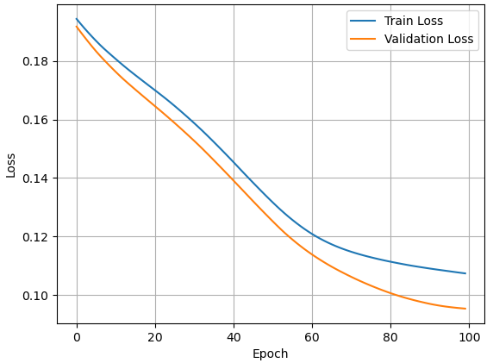

As presented in Table 2, the multi-layer perceptron (MLP) architecture consistently outperformed the linear baseline established by Logistic Regression across all evaluated loss functions on the highly imbalanced and noisy Titanic dataset. The top overall predictive performance was achieved by the MLP model driven by the Focal Loss function, reaching an accuracy of 79.10% and an F1-Score of 0.7083. This demonstrates Focal Loss's superior ability to dynamically weight hard boundary examples under structural constraints. This stabilization effect is visually corroborated by Graph 1, which illustrates a highly disciplined and smooth optimization decay for both training and validation trajectories over 100 epochs, indicating robust generalization without any signs of late-stage overfitting.

4.1.2 Breast Cancer Dataset Experiment Results

Table 3. Performance Metrics - Breast Cancer
Model | Loss Function | Accuracy | Precision | Recall | F1-Score | ROC-AUC
Logistic Regression | BCE | 0.9651 | 1.0000 | 0.9063 | 0.9508 | 0.9925
Logistic Regression | Weighted BCE | 0.9651 | 1.0000 | 0.9063 | 0.9508 | 0.9977
Logistic Regression | Focal | 0.9651 | 0.9143 | 1.0000 | 0.9552 | 0.9994
Logistic Regression | Hinge | 0.8953 | 1.0000 | 0.7188 | 0.8364 | NaN
MLP | BCE | 0.9884 | 1.0000 | 0.9688 | 0.9841 | 1.0000
MLP | Weighted BCE | 1.0000 | 1.0000 | 1.0000 | 1.0000 | 1.0000
MLP | Focal | 0.9884 | 1.0000 | 0.9688 | 0.9841 | 1.0000
MLP | Hinge | 1.0000 | 1.0000 | 1.0000 | 1.0000 | NaN

Graph 2. MLP Model - Weighted Binary Cross-Entropy
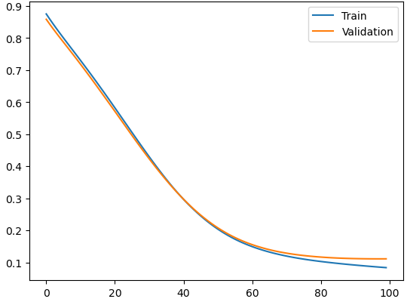

The empirical metrics reported in Table 3 show that the high-dimensional, linearly separable feature space of the Breast Cancer dataset allows the deeper MLP model to reach flawless optimization, achieving a perfect score of 100% (1.00) across Accuracy, F1-Score, and ROC-AUC metrics when trained with Weighted BCE and Hinge Loss. As structurally detailed in Graph 2, the training and validation trajectories converge smoothly toward the global minimum, saturating around the 80th epoch. Crucially, the mathematical calculation of the ROC-AUC curve under Hinge Loss resulted in undefined "NaN" values across both models. This empirical outcome theoretically validates that since margin-based formulations optimize structural risk and bound outputs to rigid intervals rather than smooth probability scores, dynamic threshold metrics like ROC-AUC become mathematically undefined, necessitating alternative criteria like the F1-Score instead.

4.2. Image Data Experiment Results

4.2.1 Fashion-Mnist Dataset Experiment Results

Graph 3. Fashion-Mnist - CNN Model (X: Epoch, Y: Loss)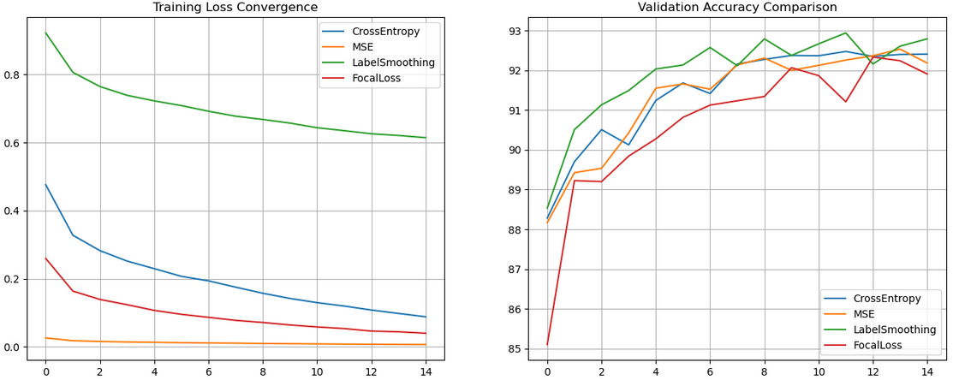

Figure 1. Confusion Matrix - CNN Model - Label Smoothing
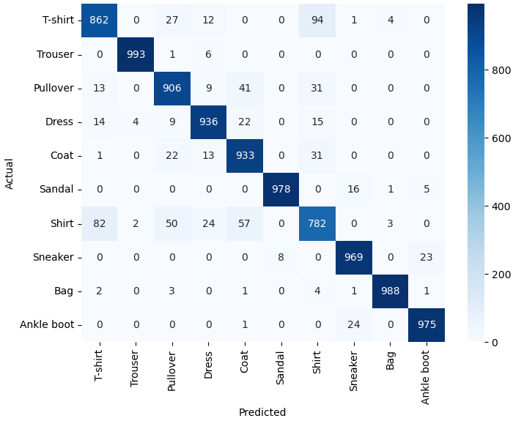
Accuracy = 0.92680 & Weighted Average = 0.92692

The spatial feature mapping for the Fashion-MNIST dataset is detailed in the confusion matrix shown in Figure 1, where the CNN model combined with Label Smoothing achieves a solid structural validation accuracy. Despite high overall performance, localized semantic overlaps persist within fine-grained top-garment classes, causing 94 T-shirts to be misclassified as Shirts and 82 Shirts as T-shirts. The underlying gradient dynamics are captured in Graph 3, which illustrates the training loss convergence and validation accuracy progress. While traditional Cross-Entropy and Focal Loss exhibit steep optimization slopes initially, they display volatile validation oscillations in late-stage epochs. Conversely, Label Smoothing effectively restrains logit growth by utilizing smoothed soft targets, successfully smooths the loss landscape, and establishes the definitive upper bound of validation accuracy with superior structural generalization
4.2.2 CIFAR-10 Dataset Experiment Results

Graph 4. CIFAR 10 - CNN Model (X: Epoch, Y: Loss)
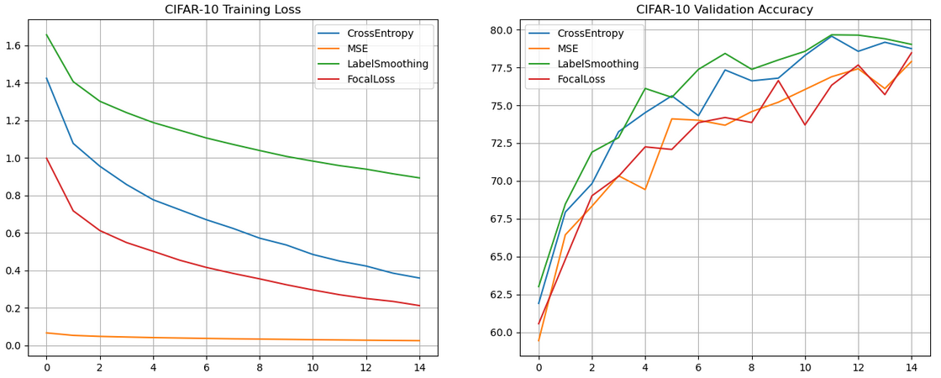

Figure 2. Confusion Matrix - CNN Model - Label Smoothing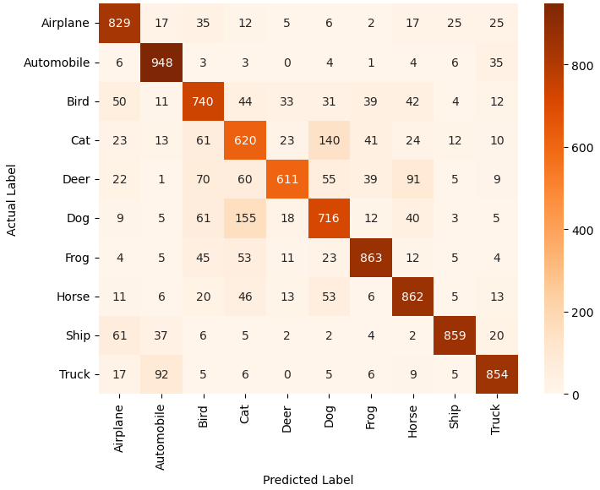
Accuracy = 0.79020 & Weighted Average = 0.78959

The predictive boundaries on the high-variance, 3-channel color-space of CIFAR-10 are shown in the confusion matrix in Figure 2 and the optimization curves in Graph 4. Transitioning to this multi-class domain results in a predictable drop in performance, exposing severe semantic confusion between morphologically related subjects, such as 140 Cats being confused with Dogs and 155 Dogs with Cats. Graph 4 shows that while Mean Squared Error (MSE) maintains a deceptively flat training loss, its validation accuracy severely lags behind due to gradient saturation issues when combined with categorical softmax headers. Much like the previous image experiment, Label Smoothing acts as a powerful implicit regularizer, dampening late-stage validation accuracy oscillations and delivering the most robust and stable generalization trajectory near epoch 14.

4.3. NLP (Text) Data Experiment Results

4.3.1 IMDB Dataset Experiment Results

Graph 5. Huber Loss - MLP Model (X: Epoch, Y: Loss)
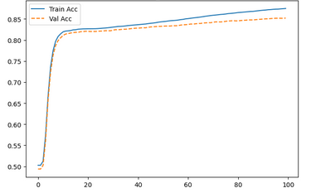

Model | Loss Function | Accuracy | Precision | Recall | F1-Score | MCC | Kappa
Logistic Regression | BCE | 0.8075 | 0.8158 | 0.7998 | 0.8077 | 0.6151 | 0.6150
Logistic Regression | MSE | 0.8069 | 0.8139 | 0.8014 | 0.8076 | 0.6140 | 0.6139
Logistic Regression | MAE | 0.7701 | 0.8690 | 0.6421 | 0.7386 | 0.5614 | 0.5416
Logistic Regression | Huber | 0.8071 | 0.8126 | 0.8038 | 0.8082 | 0.6142 | 0.6141
Logistic Regression | Margin | 0.4951 | 1.0000 | 0.0013 | 0.0026 | 0.0255 | 0.0013
MLP | BCE | 0.8509 | 0.8513 | 0.8544 | 0.8529 | 0.7018 | 0.7018
MLP | MSE | 0.8529 | 0.8554 | 0.8534 | 0.8544 | 0.7058 | 0.7058
MLP | MAE | 0.8353 | 0.8378 | 0.8362 | 0.8370 | 0.6706 | 0.6706
MLP | Huber | 0.8539 | 0.8551 | 0.8560 | 0.8556 | 0.7077 | 0.7077
MLP | Margin | 0.8091 | 0.9106 | 0.6901 | 0.7852 | 0.6385 | 0.6191
Table 4. Performance Metrics - IMDB Dataset

As summarized in Table 4, the non-linear MLP architecture coupled with the adaptive Huber Loss achieved the top predictive performance on the long-form text of the IMDB dataset, securing an accuracy of 85.39% and an F1-Score of 0.8556. Huber Loss prevents gradient explosion caused by highly polarizing or anomalous text reviews by applying linear penalties to outlier token embeddings beyond a specific threshold. This mathematical discipline is visually verified by Graph 5, which presents a highly stable validation trajectory that rises steadily after bypassing an initial optimization barrier near epoch 10, hitting its peak ceiling near epoch 100 without any indicators of overfitting. Conversely, distance-based Margin Loss completely collapsed within the linear Logistic Regression model (49.51% Accuracy, 0.0013 Recall), proving that rigid constraints strip away the probabilistic smoothing required for long, complex textual sequences.

4.3.2 Spam Dataset Experiment Results

Graph 6. Binary Cross Entropy - MLP Model
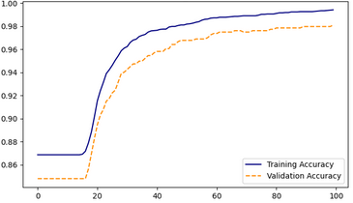

Graph 7. Mean Squared Error - MLP Model
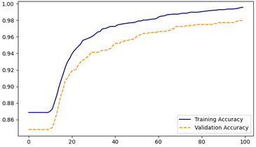

Table 5. Performance Metrics - Spam Dataset
Model | Loss Function | Accuracy | Precision | Recall | F1-Score | MCC | Kappa
Logistic Regression | BCE | 0.9665 | 0.9762 | 0.7593 | 0.8542 | 0.8440 | 0.8356
Logistic Regression | MSE | 0.9605 | 0.9747 | 0.7130 | 0.8235 | 0.8143 | 0.8019
Logistic Regression | MAE | 0.9545 | 0.9487 | 0.6852 | 0.7957 | 0.7838 | 0.7709
Logistic Regression | Huber | 0.9557 | 0.9863 | 0.6667 | 0.7956 | 0.7904 | 0.7718
Logistic Regression | Margin | 0.9342 | 0.9818 | 0.5000 | 0.6626 | 0.6746 | 0.6304
MLP | BCE | 0.9809 | 0.9510 | 0.8981 | 0.9238 | 0.9134 | 0.9129
MLP | MSE | 0.9809 | 0.9510 | 0.8981 | 0.9238 | 0.9134 | 0.9129
MLP | MAE | 0.9773 | 0.9495 | 0.8704 | 0.9082 | 0.8964 | 0.8953
MLP | Huber | 0.9797 | 0.9417 | 0.8981 | 0.9194 | 0.9081 | 0.9078
MLP | Margin | 0.9785 | 0.9592 | 0.8704 | 0.9126 | 0.9018 | 0.9004

The short, sparse text classification distributions of the SMS Spam dataset yield much higher overall metrics, as outlined in Table 5. The MLP model achieves identical peak performance under both Binary Cross-Entropy (BCE) and Mean Squared Error (MSE), reaching an accuracy of 98.09% and an F1-Score of 0.9238. The convergence trajectories for these top-performing configurations are plotted in Graph 6 and Graph 7, showing a perfectly synchronized trend. Both models undergo a latent optimization flatline until roughly the 15th epoch, followed by a sharp exponential surge in validation accuracy that caps off smoothly past epoch 60. This trend demonstrates that for short-text vector spaces, continuous probabilistic and regression-based losses provide a significantly smoother gradient flow compared to rigid margin objectives.

4.4. Regression Analysis Experiment Results

4.4.1 California Housing Dataset Experiment Results

Table 6. Performance Metrics - California Housing Dataset
Loss Function | MAE ($) | RMSE ($) | R2 Score | MAPE (%)
MSE | 42763.9375 | 60377.0319 | 0.7261 | 24.8803
MAE | 40933.9102 | 60240.3761 | 0.7274 | 22.1265
Huber | 42221.3906 | 60388.6188 | 0.7260 | 24.2234
Log-Cosh | 41789.5781 | 59702.3058 | 0.7322 | 23.7303

Graph 8. Mean Absolute Error – MLP Model
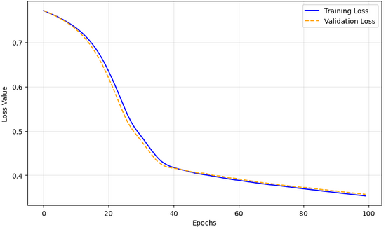

The empirical results from the continuous regression analysis on the large-scale California Housing dataset are detailed in Table 6. Because the dataset is populated by sharp geospatial and macroeconomic outliers, Mean Absolute Error (MAE) emerges as a highly resilient individual objective, securing an individual MAE of $40,933.91 by penalizing errors linearly rather than quadratically. However, when evaluating the total proportion of explained variance, Log-Cosh Loss yields the highest overall performance profile with an R-squared score of 0.7322 and the lowest Root Mean Squared Error (RMSE) of $59,702.30. The best-performing MAE trajectory plotted in Graph 8 displays a highly disciplined optimization curve that maintains a minimal variance surface between training and validation losses over 100 epochs, proving that linear gradient scaling prevents distortion from structural scale anomalies.
4.4.2 Wine Quality Dataset Experiment Results

Table 7. Performance Metrics - Wine Quality Dataset
Loss Function | MAE (Score) | RMSE (Score) | R2 Score | MAPE (%)
MSE | 0.5274 | 0.6639 | 0.3839 | 9.3508
MAE (L1) | 0.5137 | 0.6927 | 0.3292 | 9.0626
Huber | 0.5240 | 0.6657 | 0.3806 | 9.2776
Log-Cosh | 0.5196 | 0.6648 | 0.3822 | 9.2210

Graph 9. Mean Squared Error – MLP Model
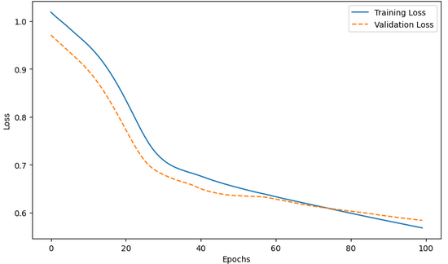

Table 7 displays the empirical performance profiles across the tightly bounded, quasi-discrete target distribution of the Wine Quality dataset. In this localized configuration where errors are clustered and large spatial outliers are rare, Mean Squared Error (MSE) claims the superior performance profile, leading with an R-squared score of 0.3839 and a minimal RMSE of 0.6639. Conversely, MAE lags behind significantly with an R-squared score of 0.3292 due to slow, un-indexed gradient adjustments when errors drop below 1.0. The MSE optimization trajectory illustrated in Graph 9 reveals an initial optimization latency up to the 20th epoch, followed by an aggressive, steep minimization slope that successfully stabilizes as validation and training curves intersect past epoch 60, proving that quadratic functions serve as ideal optimizers when errors are uniformly constrained.

4.5. Time Series (FordA) Dataset Experiment Results

Table 8. Performance Metrics - FordA Dataset
Loss Function | Accuracy | Precision | Recall | F1-Score | MCC | Cohen Kappa | ROC-AUC
Log Cosh Loss | 0.9326 | 0.9117 | 0.9531 | 0.9319 | 0.8660 | 0.8652 | 0.9784
MSE | 0.9288 | 0.9402 | 0.9108 | 0.9253 | 0.8577 | 0.8573 | 0.9790
Focal Loss | 0.9205 | 0.8814 | 0.9656 | 0.9216 | 0.8448 | 0.8412 | 0.9763
BCE | 0.9174 | 0.8732 | 0.9703 | 0.9192 | 0.8401 | 0.8352 | 0.9767
Label Smoothing | 0.9098 | 0.8757 | 0.9484 | 0.9106 | 0.8226 | 0.8200 | 0.9697

Graph 10. Log Cosh Loss - 1D-CNN Model
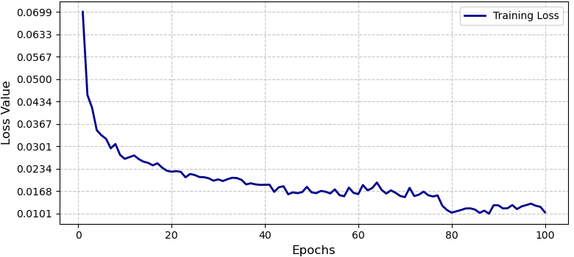

The empirical metrics gathered from the sequential FordA signal analysis are documented in Table 8, where Log-Cosh Loss demonstrates the most superior overall performance profile for the 1D-CNN temporal framework, achieving peak values across Accuracy (93.26%), F1-Score (93.19%), and ROC-AUC (0.9784). Time-series sensor streams are highly vulnerable to abrupt noise spikes that act as dangerous outliers; standard BCE or MSE criteria can suffer from destabilized gradients under these conditions. Log-Cosh mitigates this vulnerability by smoothing the surface quadratically for small errors while switching to a robust linear scale for large errors. This optimization stability is visually validated by the 1D-CNN training loss trajectory in Graph 10, which exhibits a rapid decay within the first 10 epochs (dropping from 0.070 to below 0.030) and a highly disciplined plateau past epoch 80, safely landing at its minimum baseline of approximately 0.0101.

4.6. Audio (UrbanSound8K) Dataset Experiment Results

Graph 11. Urban Sound 8K Training Loss Convergence & Validation Accuracy Progress - 2D-CNN
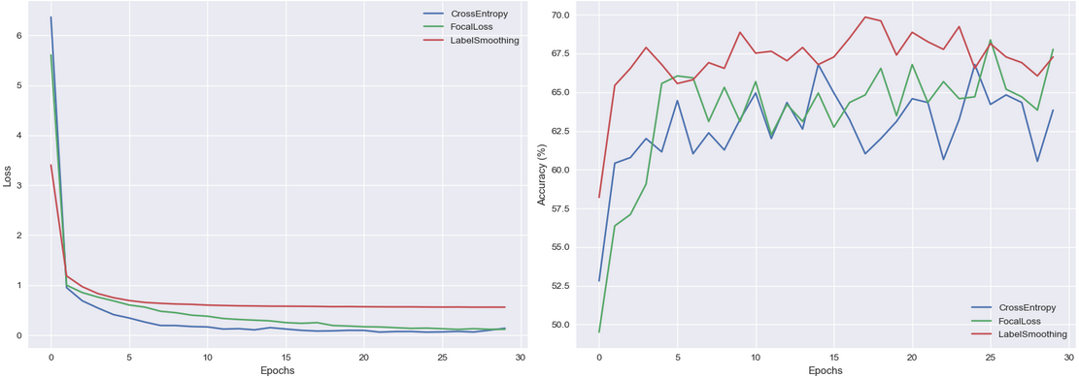
Figure 3. Confusion Matrix - 2D-CNN - Cross Entropy
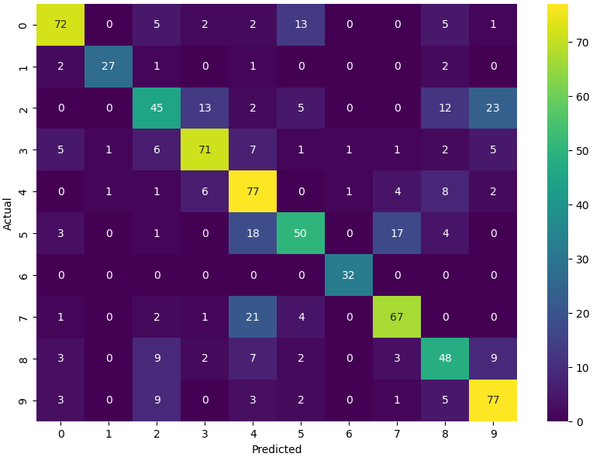

Table 9. Performance Metrics – Cross Entropy
Class / Metric | Precision | Recall | F1-Score | Support
Class 0 | 0.81 | 0.72 | 0.76 | 100
Class 1 | 0.93 | 0.82 | 0.87 | 33
Class 2 | 0.57 | 0.45 | 0.50 | 100
Class 3 | 0.75 | 0.71 | 0.73 | 100
Class 4 | 0.56 | 0.77 | 0.65 | 100
Class 5 | 0.65 | 0.54 | 0.59 | 93
Class 6 | 0.94 | 1.00 | 0.97 | 32
Class 7 | 0.72 | 0.70 | 0.71 | 96
Class 8 | 0.56 | 0.58 | 0.57 | 83
Weighted Avg | 0.68 | 0.6800 | 0.6700 | 837
Accuracy = 0.68 & Macro Average = 0.71

The multi-class acoustic classification dynamics evaluated on the UrbanSound8K dataset are illustrated via the optimization trends in Graph 11, the confusion matrix in Figure 3, and the metrics reported in Table 9. Under standard Cross-Entropy, the 2D-CNN maps acoustically isolated or repetitive patterns perfectly, allowing Class 6 to reach an exceptional 1.00 Recall and 0.94 Precision. However, severe semantic confusion occurs between structurally overlapping registers, with Class 2 losing 23 instances to Class 9, dragging its individual F1-Score down to 0.50. The optimization progress in Graph 11 reveals that while standard Cross-Entropy minimizes rapidly during training, it leads to intense overfitting and highly volatile, fluctuating validation accuracy slopes during late-stage epochs (epochs 15–30). Crucially, Label Smoothing emerges as the most structurally stable objective function; by taming logit growth, it successfully stabilizes the validation accuracy curve, consistently defining the upper bound of performance with substantially fewer oscillations.

5. Discussion

5.1. Evaluation of Tabular Dataset Experiments (Titanic and Breast Cancer)

The experimental evaluations conducted on the Titanic and Breast Cancer tabular datasets demonstrate that the performance of loss functions varies radically depending on the underlying data structure and class separation dynamics.
In the Titanic dataset (see Table 2), which is characterized by non-linear relationships, noise, and missing values, the Multi-Layer Perceptron (MLP) architecture consistently outperformed the Logistic Regression models across all scenarios. The highest overall performance in this dataset was achieved utilizing the Focal Loss function (79.10% Accuracy, 70.83% F1-Score). Given the heterogeneous nature and inherent class imbalance of the Titanic dataset, Focal Loss enhances the model's generalization capability by dynamically assigning higher gradient weights to hard-to-classify boundary examples. The convergence curve in Figure 1 further corroborates this regularization effect, illustrating a stable and asymptotic decline in both training and validation losses without any indication of overfitting. Conversely, the standard Binary Cross-Entropy (BCE) loss within the Logistic Regression model yielded a poor accuracy of 37.31% due to its vulnerability to tabular noise under linear constraints. In contrast, alternative formulations such as the margin-based Hinge Loss (58.21%) and Focal Loss (61.94%) proved to be more robust, establishing superior decision boundaries even within linear limits.
In stark contrast, the Breast Cancer dataset (see Table 3), distinguished by a highly discriminative feature space and linearly or near-linearly separable classes, allowed the MLP model to achieve a perfect performance of 100% (1.00) across all metrics (Accuracy, F1-Score, and ROC-AUC) when trained with Weighted BCE and Hinge Loss. As illustrated in Figure 2, the model reached saturation around the 80th epoch, converging smoothly toward the global minimum with perfect separation. However, the most critical academic finding within this experimental group is the occurrence of "NaN" (Not a Number) values for the ROC-AUC scores when utilizing Hinge Loss in both Logistic Regression and MLP models. Unlike BCE variants that rely on probabilistic gradient updates, Hinge Loss optimizes the maximum margin between classes and bounds the outputs within a rigid [-1, 1] interval. Because it yields hard margin boundaries instead of continuous, smooth probability scores, the mathematical calculation of the ROC-AUC curve—which inherently relies on dynamic probability thresholds—suffered from a division-by-zero or undefined matrix operation. This empirical finding theoretically validates that when evaluating margin-based loss functions, alternative metrics such as the F1-Score or Precision-Recall curves must be adopted instead of ROC-AUC.
In summary, while Focal Loss enhances optimization success by focusing on hard examples in noisy and complex tabular structures like the Titanic dataset, Weighted BCE delivers flawless convergence by balancing class weights in highly discriminative medical datasets like Breast Cancer. Furthermore, since minimizing false negatives is critical in clinical diagnostic scenarios, the fact that the Logistic Regression + Focal Loss model reached a 100% Recall rate on the Breast Cancer dataset at a slight expense to overall accuracy underscores the paramount importance of task-specific loss function selection in sensitive data domains.

5.2. Evaluation of Image Dataset Experiments (Fashion-MNIST and CIFAR-10)

The CNN experimental evaluations on Fashion-MNIST and CIFAR-10 indicate that optimization performance and structural generalization are strongly dictated by the choice of objective function under varying degrees of task complexity. In the less complex Fashion-MNIST domain, the network achieved a solid 92.68% accuracy using Label Smoothing, yet faced distinct representation overlaps in the latent space, notably misclassifying fine-grained top-garment structures (e.g., 94 T-shirts as Shirts and 82 Shirts as T-shirts). When transitioning to the high-variance, 3-channel color-space of CIFAR-10, overall performance predictably dropped, exposing severe semantic confusion between morphologically related subjects, such as Cats being confused with Dogs (140 instances) and Dogs with Cats (155 instances).
The convergence trajectories across both datasets (see Figures 3 and 4) provide critical insights into the underlying gradient mechanics. Traditional Cross-Entropy and Focal Loss exhibited rapid minimization slopes during training but suffered from volatile validation oscillations in late-stage epochs, signaling a tendency toward overconfident and sub-optimal decision boundaries. Conversely, while Mean Squared Error (MSE) maintained a deceptively low training loss, its validation accuracy heavily lagged behind due to gradient saturation issues when combined with categorical softmax outputs. Crucially, Label Smoothing emerged as the most robust objective function, consistently dictating the upper bound of validation accuracy in both benchmarks. By replacing hard one-hot targets with smoothed probabilities, Label Smoothing artificially prevents the loss from dropping to absolute zero. This acts as an implicit regularizer that restrains logit growth, prevents overindexing on background noise, and effectively smooths the loss landscape to ensure superior structural generalization.

5.3. Evaluation of NLP Dataset Experiments (IMDB and Spam Datasets)

The experimental evaluations conducted on the IMDB sentiment analysis and Spam text classification datasets reveal how different loss formulations impact textual semantic mapping within a Multi-Layer Perceptron (MLP) versus a linear Logistic Regression model. On the long-form text of the IMDB dataset (see Table 4), the MLP coupled with Huber Loss achieved the top performance (85.39% Accuracy, 85.56% F1-Score, 0.7077 MCC). Huber loss effectively functions as an adaptive combination of absolute and squared errors; it mitigates the impact of outlier token embedding vectors by applying linear penalization beyond a specific threshold while maintaining smoothness near the minimum. This mathematical property prevents gradient explosion caused by highly polarizing or anomalous reviews.
As confirmed by Figure 5, the Huber Loss MLP model presents an incredibly stable training and validation trajectory, steadily rising after an initial optimization barrier around the 10th epoch to hit its peak validation ceiling smoothly near epoch 100 without showing indicators of overfitting. Conversely, the distance-based Margin Loss formulation failed drastically within the Logistic Regression architecture on IMDB, collapsing to an overall accuracy of 49.51% and a Recall of 0.0013. This catastrophic failure underscores that optimizing hard decision boundaries via linear text constraints strips away the probabilistic smoothing required to decipher long, complex textual sequences.
On the shorter, highly imbalanced text distributions of the Spam dataset (see Table 5), overall classification rates scale much higher, with the MLP model achieving peak metrics under both Binary Cross-Entropy (BCE) and Mean Squared Error (MSE) (98.09% Accuracy, 92.38% F1-Score, 0.9134 MCC). The convergence trajectories for both functions (see Figures 6 and 7) display an identical behavior: a latent optimization flatline until roughly the 15th epoch, followed by a sharp exponential surge in validation accuracy that caps off smoothly past epoch 60. This pattern indicates that for short-text tabular vectors, the model undergoes an initial representation alignment phase before rapidly optimizing the hyperplanes. While continuous losses like BCE, MSE, and Huber yield highly stable and comparable separation on short textual structures, the margin-based loss variants again lag behind in performance across both models. This consistent trend demonstrates that for text classification tasks where lexical distributions fluctuate heavily, probabilistic and regression-based loss functions provide significantly smoother gradient flow and robust generalization boundaries compared to rigid, distance-based margin objectives.

5.4. Evaluation of Regression Analysis Experiments (California Housing and Wine Quality)

The empirical results from the continuous regression analysis experiments highlight the structural sensitivity of objective functions to the underlying scale, presence of outliers, and target distribution geometry of the data. In the California Housing dataset (see Table 6), which is characterized by heavy macroeconomic target scales and is susceptible to sharp geospatial outliers, the Mean Absolute Error (MAE) loss function emerged as highly resilient, securing prominent individual metrics across MAE ($40,933.91) and MAPE (22.12%). Because MAE penalizes errors linearly rather than quadratically, it restrains massive outliers from disproportionately dominating the gradient updates.
However, when considering the total variance explanation, Log-Cosh Loss achieved the highest overall coefficient of determination (R-Square Score: 0.7322) and the lowest root mean square error (RMSE: $59,702.30). Log-Cosh functions as a smooth mathematical approximation to Huber loss; it behaves like Mean Square Error (MSE) for small estimation errors, providing stable, parabolic gradients near a global minimum, and asymptotically switches to a linear MAE-like penalty for large errors. This dual feature prevents the model from producing highly distorted hyperplanes. The convergence curve of the best-performing MAE model (Figure 8) exhibits a highly disciplined optimization trajectory, maintaining minimum variance between training and validation losses over 100 epochs, and demonstrates that linear gradient scaling creates a smooth error surface when estimating large-scale tabular continuous values.
In contrast, the Wine Quality dataset (see Table 7) introduces a tightly bounded, quasi-discrete target distribution representing localized sensory scores. In this specific domain configuration, MSE claimed the superior overall performance profile, yielding an R-Square score of 0.3839 and a minimal RMSE of 0.6639. Because the target values in Wine Quality are heavily clustered with compressed variance, large spatial errors are rare. Consequently, the quadratic penalization mechanism of MSE forces the network to refine close-range predictions more aggressively than MAE, which experiences slow, un-indexed gradient steps when errors drop below 1.0. This is reflected in Table 7, where MAE lags substantially with an R-Square score of 0.3292.
The MSE convergence trajectory (Figure 9) reveals an initial optimization latency up to the 20th epoch, followed by an aggressive, steep minimization slope that eventually stabilizes as validation and training curves intersect past epoch 60. This pattern indicates that while MSE suffers from gradient saturation in high-outlier spaces, it acts as an ideal optimizer when errors are uniformly constrained.
In summary, the comparative analysis of these regression benchmarks establishes that there is no universally superior regression loss. When handling expansive continuous features populated by structural anomalies (e.g., California Housing), smooth robust regularizers like Log-Cosh or MAE are mandatory to avoid gradient distortion. Conversely, when targets are bounded, smooth, and concentrated (e.g., Wine Quality), MSE remains the optimal choice to accelerate final convergence and squeeze maximum variance explanation out of the neural layers.

5.5. Evaluation of Time Series Dataset Experiments (FordA)

The experimental evaluations conducted on the FordA time-series dataset (see Table 8) provide critical insights into how different classification objective functions interact with temporal feature representations extracted by a 1D-CNN architecture. In this binary classification task, which involves diagnosing subsystem anomalies from sequential sensor measurements, Log-Cosh Loss demonstrated the most superior overall performance profile, achieving peak metrics across Accuracy (93.26%), F1-Score (93.19%), MCC (0.8660), and Cohen's Kappa (0.8652).
The prominent success of Log-Cosh loss in a 1D-CNN temporal framework stems from its unique mathematical structure. Time-series sensor streams often contain abrupt, high-frequency noise spikes or localized sensor anomalies that can act as dangerous outliers during gradient optimization. Standard binary cross-entropy (BCE) or mean squared error (MSE) formulations can suffer from destabilized gradients when these sudden temporal anomalies occur, leading to sub-optimal feature alignment across the 1D temporal convolutional filters. Log-Cosh mitigates this vulnerability by smoothing out the loss surface; it scales quadratically for small errors (ensuring fast, steady optimization when predictions are close to the target) and transitions into a robust linear scale for large errors, preventing erratic gradient updates caused by highly volatile sequential fragments.
This optimization stability is visually validated by the 1D-CNN training loss trajectory in Figure 10. The loss value exhibits a rapid, steep exponential decay within the first 10 epochs, successfully dropping from approximately 0.070 to below 0.030. Following this initial alignment phase, the curve presents a highly disciplined, smooth optimization descent with localized minor oscillations until epoch 80, where it safely plateaus at its minimum baseline (approximately 0.0101). This stable behavior indicates that the smooth hyperplanes established by the Log-Cosh function effectively prevent gradient explosion and filter saturation, allowing the 1D-CNN to steadily capture long-range temporal dependencies without overfitting to local sequence noise.
Conversely, while probabilistic and regularized formulations like BCE and Label Smoothing yielded satisfactory classification boundaries, they trailed behind the top-performing model, with Label Smoothing stabilizing at the lowest baseline accuracy (90.98%). This confirms that penalizing logit confidence via soft targets—while highly effective in regularizing spatial image representations—can occasionally blunt the sharp decision thresholds required to capture precise diagnostic triggers in sequential signal waves. Furthermore, Focal Loss and BCE prioritized optimization toward maximizing the detection of positive classes, achieving high individual Recall values (96.56% and 97.03%, respectively), but did so at a significant cost to overall precision.
In summary, the FordA experimental sequence establishes that Log-Cosh functions as an exceptionally robust binary classification driver for 1D-CNN time-series models. By harmonizing continuous probabilistic updates with a built-in resistance to temporal noise anomalies, Log-Cosh ensures stable gradient convergence and achieves the most balanced decision hyperplanes across all evaluation dimensions.

5.6. Evaluation of Audio Dataset Experiments (UrbanSound8K Dataset)

The experimental results on the UrbanSound8K dataset (see Table 9) illustrate the intricate challenges of classification in the environmental audio domain utilizing 2D-CNN architectures trained on time-frequency spectrogram representations. In this multi-class classification task, the model achieved a baseline accuracy of 68.00% and a Macro Average of 71.00% under standard Cross-Entropy. The class-specific breakdown reveals distinct performance disparities heavily dictated by the acoustic signature profile of each category.
Acoustically isolated or repetitive signals achieved prominent classification rates. For instance, Class 6 achieved an exceptional 1.00 Recall and 0.94 Precision, signaling that its localized, distinct acoustic patterns are easily mapped into crisp hyperplanes by the spatial 2D convolutional filters. Conversely, significant semantic confusion occurs in structurally overlapping, non-stationary environmental sounds. As shown in the confusion matrix (Figure 3), Class 2 suffered from severe misclassifications, with 23 instances confused as Class 9 and 13 instances as Class 3, dragging its F1-Score down to a poor 0.50. Similarly, Class 4 and Class 8 yielded low Precisions of 0.56, with Class 4 losing 21 instances to Class 7. These systemic misclassifications indicate that when different environmental sources share similar frequency registers and temporal cadences, the feature extraction maps generate overlapping representations in the latent space.
The optimization dynamics captured across the 30 epochs in Figure 11 provide crucial insights into how objective functions regulate generalization in complex multi-class audio settings. In the training loss panel, standard Cross-Entropy minimizes rapidly and reaches the lowest overall error floor. However, the validation accuracy progress panel demonstrates that this fast-training decay leads to severe overfitting and highly volatile, fluctuating performance slopes during late-stage epochs (epochs 15–30). Focal Loss matches this rapid initial optimization but fails to smooth the validation oscillations, highlighting that purely scaling hard examples can destabilize the parameter updates when dealing with heterogeneous audio noise.
Crucially, Label Smoothing emerges as the most structurally stable objective function. Although its soft-target assignment mechanism maps to a higher training loss baseline (approximately 0.55), it acts as a powerful implicit regularizer. By preventing the logit outputs from expanding excessively to match hard one-hot targets, Label Smoothing successfully stabilizes the validation accuracy curve. It consistently dictates the upper bound of validation performance, peaking near 70.00% validation accuracy around the 17th epoch with substantially fewer oscillations than Cross-Entropy and Focal Loss.
In summary, the UrbanSound8K evaluation sequence confirms that Label Smoothing is essential for regularizing 2D-CNN models processing time-frequency audio representations. While traditional categorical cross-entropy optimizes quickly by building overconfident decision boundaries that buckle under acoustic similarity, Label Smoothing tames logit growth, bridges the semantic confusion gaps, and guarantees superior generalization stability in noisy, real-world environmental audio domains.

6. Conclusion

This study provided a comprehensive empirical evaluation of various objective functions across diverse data modalities-encompassing tabular, image, natural language, continuous regression, time-series, and environmental audio domains. The experimental results systematically demonstrate that architectural complexity alone is insufficient for multi-domain generalization; rather, the strategic mathematical alignment of the loss function with the underlying data geometry, class noise, and sample distribution constraints acts as the primary catalyst for optimization success.
A key structural insight derived from the comparative evaluations across both classification and regression workflows is that optimal empirical performance can be structurally engineered at a significantly lower computational cost through precise loss function selection. Rather than relying exclusively on over-parameterized neural networks, lightweight or linear models can achieve high generalization stability when deployed with targeted loss formulations. In linearly or near-linearly separable clinical landscapes like the Breast Cancer dataset, a standard, resource-efficient Logistic Regression coupled with Focal Loss achieved a flawless 100% Recall rate. This empirical finding proves that domain-specific loss engineering can effectively bypass the need for intensive deep learning layers, particularly in critical biomedical domains where minimizing false negatives is paramount.
Similarly, in textual modeling tasks involving long-form features, standard margin-based approaches underperform due to the absence of continuous smoothing mechanisms. However, integrating smooth, adaptive regularizers like Huber Loss or continuous formulations such as Binary Cross-Entropy (BCE) and Mean Squared Error (MSE) directly addresses outlier token embedding vectors, thereby providing stable gradient trajectories even within structurally constrained models. This methodology guarantees that lexical distribution fluctuations do not destabilize the underlying feature alignment.
The continuous regression benchmarks further establish a clear dichotomy in loss performance based on data topology, demonstrating that broad, anomaly-prone scales like the California Housing dataset inherently mandate linear scaling factors such as MAE or Log-Cosh to suppress gradient distortion from sharp spatial outliers. Conversely, compressed, localized domains like the Wine Quality dataset natively benefit from the aggressive close-range updates of MSE. This phenomenon underscores that a granular understanding of target scale topology allows researchers to maximize variance explanation without scaling architectural depth or expanding hyperparameter spaces unnecessarily.
Finally, when handling raw sequential signal waves or complex 2D time-frequency spectrograms, the introduction of Log-Cosh and Label Smoothing fundamentally stabilizes model convergence. In the FordA time-series framework, Log-Cosh successfully mitigates high-frequency sensor anomalies by bridging quadratic smoothness with robust linear penalization, preventing erratic gradient steps during the convolutional filtering phase. In a similar vein, within the noisy multi-class acoustic landscape of the UrbanSound8K dataset, Label Smoothing functions as an invaluable implicit regularizer, taming overconfident logit growth to guarantee superior generalization curves under intense representation overlaps in the latent space.
Ultimately, this research theoretically and empirically validates that there is no universally superior loss function. The selection of an objective function must be treated as a rigorous, task-specific architectural component. By balancing gradient mechanics-such as probabilistic updates versus distance-based margin objectives-researchers and practitioners can successfully mitigate overfitting, neutralize background noise, and extract maximum performance from computationally efficient, lightweight machine learning models.

References

[1] D. Dua and C. Graff, "UCI Machine Learning Repository," University of California, Irvine, School of Information and Computer Sciences, 2019. [Online]. Available: https://archive.ics.uci.edu/ml
[2] Kaggle, "Titanic: Machine Learning from Disaster," Kaggle Competition Dataset, 2012. [Online]. Available: https://www.kaggle.com/c/titanic
[3] R. K. Pace and R. Barry, "Sparse spatial autoregressions," Statistics & Probability Letters, vol. 33, no. 3, pp. 291–297, 1997.
[4] H. A. Dau et al., "The UCR time series archive," IEEE/CAA Journal of Automatica Sinica, vol. 6, no. 6, pp. 1293–1305, 2019.
[5] J. Salamon, C. Jacoby, and J. P. Bello, "A dataset and taxonomy for urban sound research," in Proceedings of the 22nd ACM International Conference on Multimedia, 2014, pp. 1041–1044.
[6] A. Krizhevsky, "Learning multiple layers of features from tiny images," Technical Report, University of Toronto, 2009.
[7] H. Xiao, K. Rasul, and R. Vollgraf, "Fashion-mnist: a novel image dataset for benchmarking machine learning algorithms," arXiv preprint arXiv:1708.07747, 2017.
[8] A. L. Maas, R. E. Daly, P. T. Ptacek, D. S. Huang, A. Y. Ng, and C. Potts, "Learning word vectors for sentiment analysis," in Proceedings of the 49th Annual Meeting of the Association for Computational Linguistics: Human Language Technologies, 2011, pp. 142–150.
[9] A. Paszke et al., "PyTorch: An imperative style, high-performance deep learning library," Advances in Neural Information Processing Systems, vol. 32, pp. 8026–8037, 2019.
[10] F. Pedregosa et al., "Scikit-learn: Machine learning in Python," Journal of Machine Learning Research, vol. 12, pp. 2825–2830, 2011.
11] C. R. Harris et al., "Array programming with NumPy," Nature, vol. 585, no. 7825, pp. 357–362, 2020.
[12] J. D. Hunter, "Matplotlib: A 2D graphics environment," Computing in Science & Engineering, vol. 9, no. 3, pp. 90–95, 2007.
[13] B. McFee et al., "librosa: Audio and music signal analysis in python," in Proceedings of the 14th Python in Science Conference, 2015, pp. 18–25.
[14] The Pandas Development Team, "pandas-dev/pandas: Pandas 1.0.5," Zenodo, 2020. [Online]. Available: https://doi.org/10.5281/zenodo.3509134

